BIT VECTOR – INFORMATION RETRIEVAL

Tree Structure:

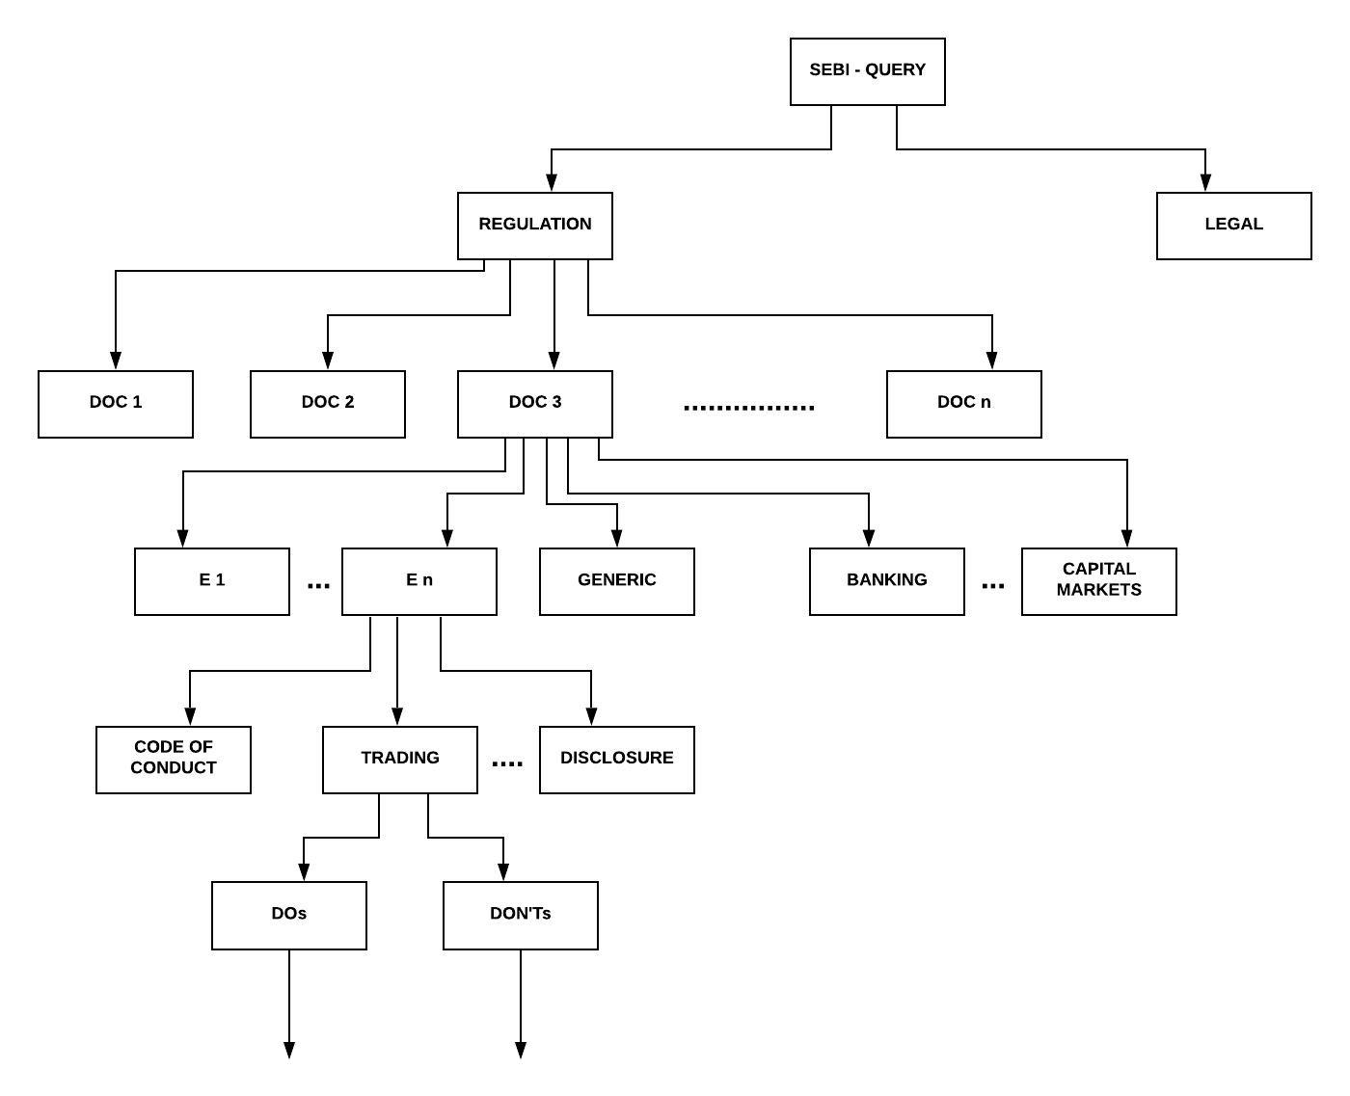
Working Principle:

1. Query -> Use case

- Legal tag – if legal cases related terms present in queries
- Regulatory tag - Otherwise

2. Use case -> Document

- LDA – Topic modelling.
- Signature Files – Hash indexing of terms.

3. Document -> Entities and special tags

- If entities in the list from the matched document(s) are present in the queries (first n bits).
- No matching entities – generic (n+1-th bit).
- Special tags mention or terms related to the tags (the rest of the bits).

4. Entities -> Regulation tags

- Regulation specific words present in queries.
- If nothing found, it means all details required – all bits set to 1 and finally regulations under them are unionized.

5. Regulation tags -> dos/dont’s

- If specifically mentioned in queries.
- If not, then both set to 1.

Special tags: banking, insurance, capital market and commodities market.

Capital market:

SEBI’s primary functions include protecting investor interests, promoting and regulating the Indian securities markets. All financial intermediaries permitted by their respective regulators to participate in the Indian securities markets are governed by SEBI regulations, whether domestic or foreign. Foreign Portfolio Investors are required to register with DDPs in order to participate in the Indian securities markets.

EXAMPLE QUERIES //Semantic layer

Q1. What are the prohibitions on communication relating to insider trading?

E1 – insider
E2 – unpublished info
E3 – board of directors
R3 – communication regulation

Reg. Legal
1 0

doc1........ PIT ........... doc_n
0 ......... 1 ........... 0

E1 E2 E3........En G B I CM COMM
1 1 1 ........ 1 1 0 0 0 0

R3 R4 ........ Rn (for all entities)
1 0 ........ 0

insider – 1 0 0 0 0
unpub. - 0 0 1 1 1
bod - 0 1 0 0 0

union - 1 1 1 1 1

Result: 3(1), 3(2), 3(3), 3(4), 3(5)

Q2. What are the trading plan regulations to be followed by an insider?

E1 – insider
E3 – trading plan
R5 – trading plan regulation

Reg. Legal
1 0

doc1........ PIT ........... doc_n
0 ......... 1 ........... 0

E1 E2 E3........En G B I CM COMM
1 0 1 ........ 0 1 0 0 0 0

R3 R4 R5 ........ Rn
0 0 1 ........ 0

insider – 1 1 0 1 0
tradingp - 0 1 0 1 0

union - 1 1 0 1 0

Result: 5(1), 5(2), 5(4)

Q3. What are the regulations to be complied by IB companies under moral code of conduct?

B - Banking
R8, R9 – Regulations related to code of conduct

Reg. Legal
1 0

doc1........ PIT ........... doc_n
1 ......... 1 ........... 1

E1 E2 E3........En G B I CM COMM
1 1 1 ........ 1 1 1 0 0 0

R3 R4 ... R8 R9 ..... Rn (for all entities)
0 0 ... 1 1 ..... 0

1. CR <- Union of final regulations under all entities
2. Rules <- Intersection of CR and final regulations under Banking

Result: Rules

Q4. Who reviews the trading plan? (Finding the entity)

E1 – insider
E2 – trading plan
E3 – compliance officer
R5 – trading plan regulation

Reg. Legal
1 0

doc1........ PIT ........... doc_n
0 ......... 1 ........... 0

E1 E2 E3........En G B I CM COMM
1 1 1 ........ 1 1 0 0 0 0

R3 R4 R5 ........ Rn (for all entities)
0 0 1 ........ 0

insider – 1 0 0 1 0
tradingp - 0 1 0 1 0
c_officer - 0 0 1 0 1

5(3) is tagged with the word ‘review’.

Result: Compliance officer. 5(3)

